**Custom Characters**

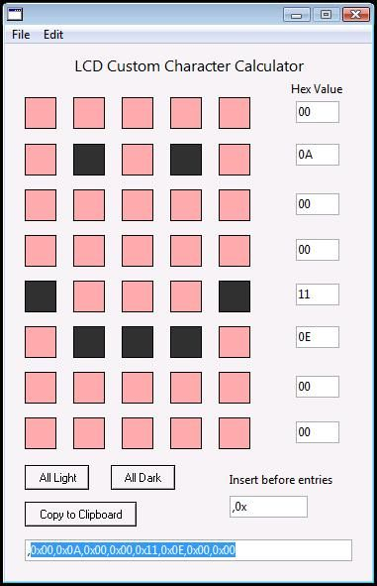

NOTE: to use this feature, you will need Arduino - 0017 or higher.  
Now what we will need to do is download LCD CUSTOM CHAR CREATOR.exe  (download below)  
Also open the Arduino IDE and copy and paste Arduino_custom_char_example.txt into the IDE.  
  
Open up LCD CUSTOM CHAR CREATOR.exe and type ",0x" into the "Insert before entries" box.  
Then click on the pixels to create a character. (I made a smiley)  
Then, copy the hex code (highlited in the picture to this part in the IDE:

uint8_t custom_hex1[8] = {**0x00,0x0A,0x00,0x11,0x0E,0x00,0x00,0x00**};  
  
NOTE: on the program, it has a comma at the beginning, so just highlight the text after the first comma, and press CTRL+C to copy.

#include <LiquidCrystal.h>

LiquidCrystal lcd(12, 11, 2, 7, 8, 9, 10);

smiley[8] = {0x00,0x0A,0x00,0x11,0x0E,0x00,0x00,0x00}; //a custom HEX character

void setup()

{

lcd.begin(16, 2);

lcd.createChar(1, smiley);

lcd.home();

lcd.print(1, BYTE);

}

void loop(){}